

LAB REPORT
CSE232: Compiler Design Lab

01
[Report Number]

Topic: Write a Flex program to recognize the following types of strings.

Submitted To
Mushfiqur Rahman Chowdhury (MRC)
Lecturer
Department of CSE, Daffodil International University

Submitted By
Student ID: 0242220005101781
Section: 63 N
Student Name: SHAHARIAR HOSSAIN

Date of Assignment Distribution: 10 November 2025
Date of Assignment Submission: 18 November 2025

Experiment No: 01 |  | Mapping: CO1 and CO2
Experiment Name | Write a Flex program to recognize the following types of strings.
Experiment Details:
Lexer.l:
%{
#include <stdio.h>
%}

%option noyywrap

%%
^[a-zA-Z_][a-zA-Z0-9_]*[0-9]$ { printf("Matched: %s\n", yytext); }
.|\n { /* Ignore any other characters or newlines */ }
%%

int main(int argc, char **argv) {
if (argc > 1) {
FILE *f = fopen(argv[1], "r");
if (!f) { perror(argv[1]); return 1; }
yyin = f;
}
yylex(); // Start the lexical analysis
return 0;
}
tests.txt:
test_456
_123test
123abc
a1
_var9
abc_123
a_bc
1abc9
Z0
_9
a0
A_1b
__0
abc123
abc_
_
a
a9_
Command:
flex lexer.l
clang lex.yy.c -o lexer
./lexer tests.txt

Obtained Output:

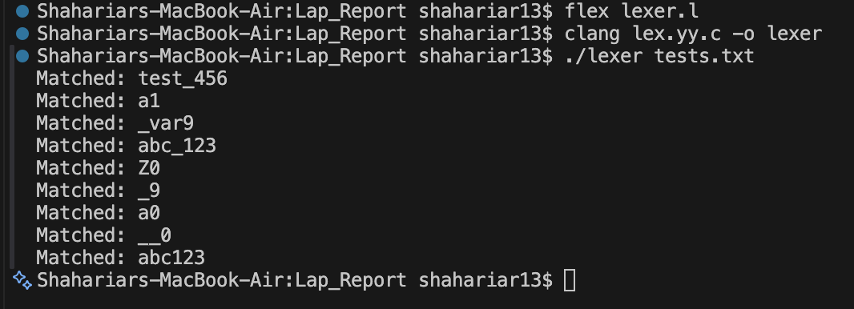 | Desired Output?
 | YES
Alternative Steps/Solution (If any):
%option noyywrap

- Solution to Missing libfl Library on macOS:
On macOS, if the libfl library is missing, a suitable solution is to add the %option noyywrap directive in the Flex file. This directive disables the default yywrap() function, which is typically part of the libfl library. By using %option noyywrap, the program no longer requires libfl to run, thereby resolving the issue when the library is unavailable.
Observation/ Comments:
The addition of the %option noyywrap directive resolves the issue of missing libfl on macOS by disabling the yywrap() function, which eliminates the need for the Flex library during compilation.

Appendix A: Course Outcomes, Complex Engineering Problems (EP) and Complex Engineering Activities (EA) Addressing.

Table: CSE312 Course Outcomes (COs) with Mappings
COs | CO Statements | POs | Learning  Domains | Knowledge  Profile | Complex  Engineering  Problem | Complex Engineering  Activities
CO1 | Demonstrate a comprehensive understanding of fundamental database management concepts, including the relational data model, normalization techniques, and SQL basics. | PO1 | C2  A2  P2 | K2  K3  K4  K8 | EP1  EP4
CO2 | Design, implement and optimize relational databases, incorporating advanced SQL queries, indexing techniques and query optimization strategies. | PO3 | C3  A3  P3 | K2  K3  K4  K6  K8 | EP1  EP2  EP7 | EA3
CO3 | Understand and Analyze security measures, distributed database architectures and emerging trends in database management, demonstrating an understanding of the broader context and challenges in the field. | PO5 | C4  A4  P3 | K6 | EP4

Table: Addressing CO (1 to 3), Knowledge Profile (K), Attainment of Complex Engineering
Problems (EP):
SN | Engineering Problem (EP) Definition | Attain  Ment | CO | Justification  (with Knowledge Profile)
01 | EP1: Depth  of  Knowledge  required | Yes/No | CO1, CO2
02 | EP2: Range  of  Conflicting  Requirement  s | Yes/No | CO2
03 | EP4:  Familiarity  of Issues | Yes/No | CO1, CO3
04 | EP7:  Interdependence | Yes/No | CO2

Table: Addressing COs
SN | COs | Attainment | Justification
01 | CO1 | Yes/No | These Lab activities attain CO1 by.
02 | CO2 | Yes/No | N/A
03 | CO3 | Yes/No | These Lab activities attain CO3 by.

Table: Lab-Wise Recommended Topics

Lab Class No. | Proposed Activity
Lab 1 | Write a Flex program to recognize the following types of strings.
Lab 2 | Write a Flex program to recognize the following types of strings.
Lab 3 | Write a calculator using Flex and Bison that supports

